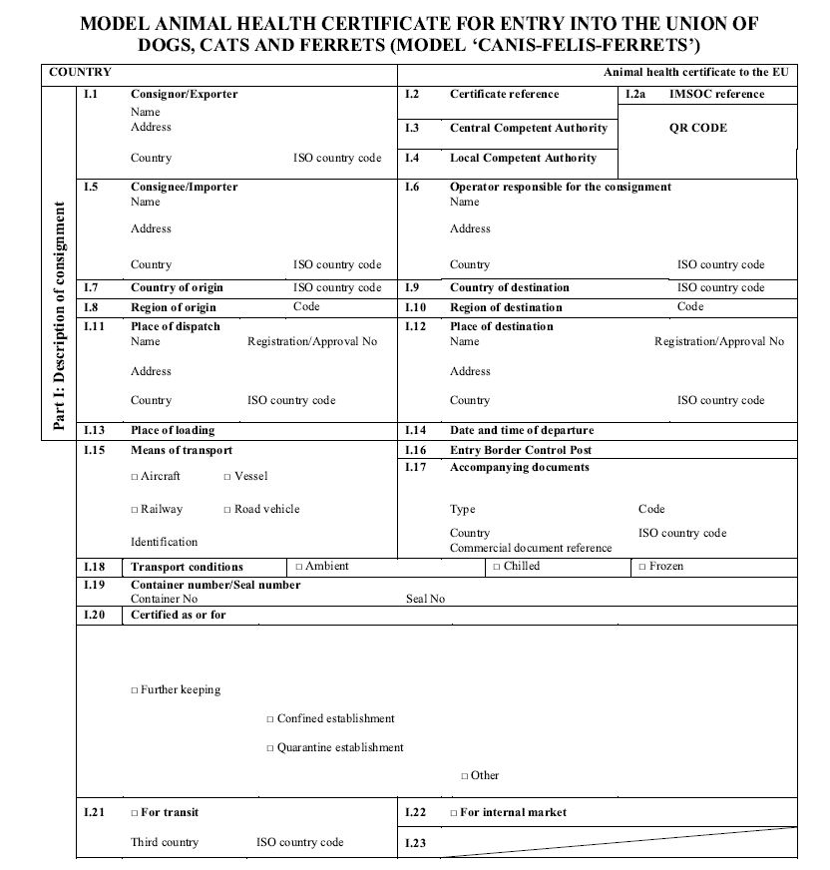

check the box as appropriate

First EU border where the pet will enter the EU

dd.mm.yyyy

Name of airport

check the box as appropriate

name

address

Approval number

In the EU (destination)

completed by offical vet

name

address

Approval number

In country of origin

completed by offical vet

Country of origin

*Must be filled in by competent authority (certificate reference no on every page)*

Consignee’s name

Consignee’s address

Consignee’s phone number

**In the EU!**

Consignor’s name

Consignor’s address

Consignor’s phone number

**In the country of origin!**

**Country of origin**

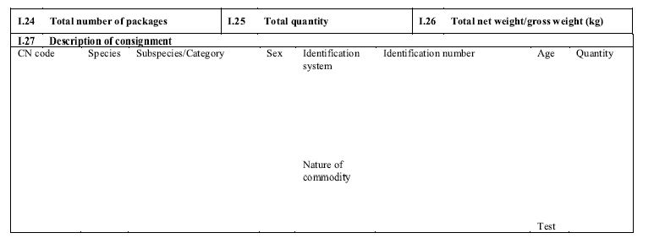

*Each animal must be 15 digit microchip or tattoo no 15 digit microchip or*

*listed individually:* (tattoo must have been *tattoo number* Date format must be

**Dog:** *Canis familiaris* applied before *3 July 2011*) (tattoo must have been day/month/year

**Cat***: Felis catus* applied before *3 July 2011*)

**Ferret***: Mustela putorius furo*

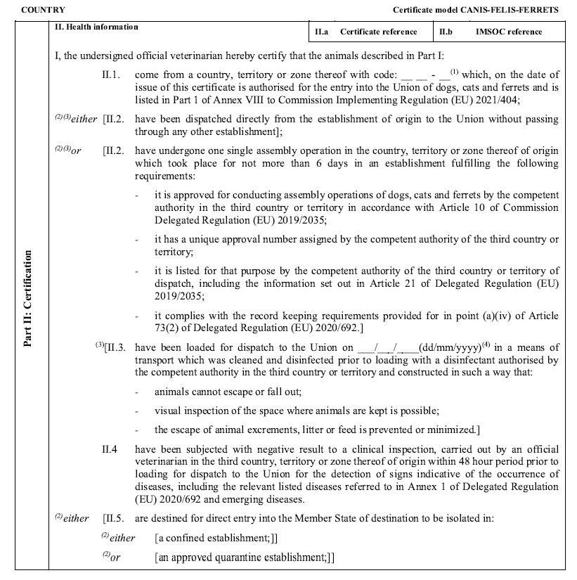

*The health certificate should be issued 48 hours prior to the time of departure, or a certified copy of the competent authority shall be attached.*

*Choose one of the options. Keep as appropriate*

*Choose one of the options. Keep as appropriate*

*must be filled in by competent authority*

**Country of origin**

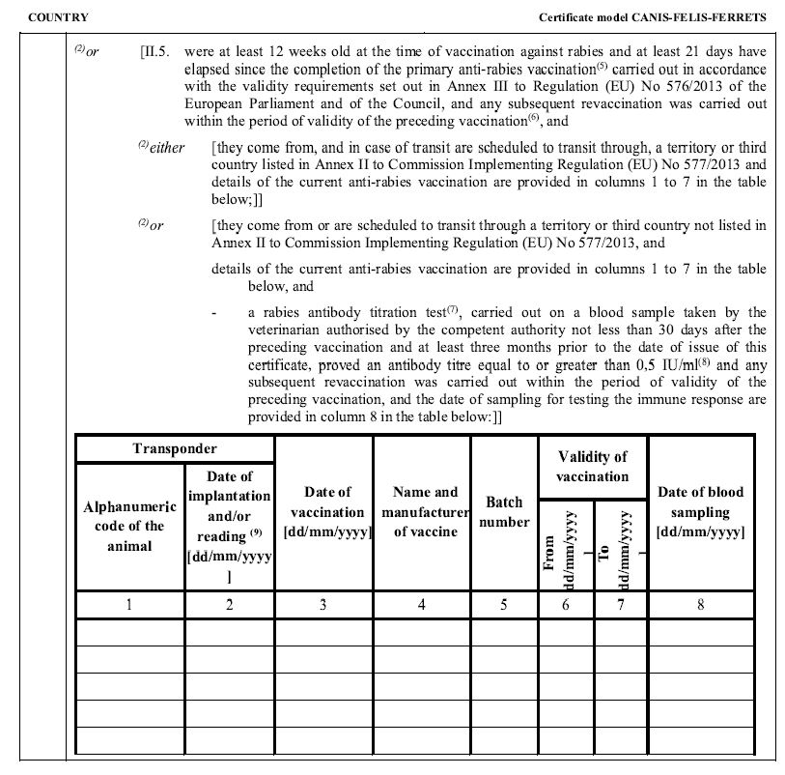

*8*

*Countries other than those listed in Annex II: rabies anti-body titration test (blood sample) at least 30 days after the preceding vaccination and not less than 3 months prior to the date of import (titer ≥ 0,5IU/ml serum)*

*Fill in the validity of the rabies vaccination as stated in the pet passport/ vaccination record*

*Fill in the validity of the rabies vaccination as stated in the pet passport/ vaccination record*

*Fill in the batch number of the rabies vaccination as stated in the pet passport/ vaccination record*

*the date of administration of the rabies vaccine may not precede the date of marking or reading of the transponder or tattoo*

*You have to show a verification*

*the date of administration of the rabies vaccine may not precede the date of marking or reading of the transponder or tattoo*

*You have to show a verification*

*Date of implantation or reading must be on the same date before the rabies vaccination*

*15 digit microchip or tattoo number (tattoo must have been applied before 3 July 2011)*

*Choose one of the options. Keep as appropriate*

*must be filled in by competent authority*

**Country of origin**

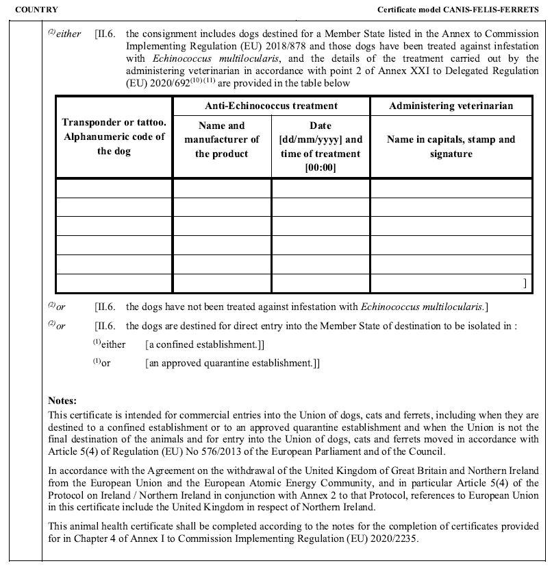

*Name, stamp and signature of the administered veterinarian*

*Has to be administered by a veterinarian within a period of not more than 120 hours and not less than 24 hours before the time of the scheduled entry of the dogs*

*Fill in the manufacturer*

*15 digit microchip or tattoo number (tattoo must have been applied prior to 3 July 2011)*

only for dogs travelling to Norway, UK, Malta, Ireland or Finland

*Choose one of the options. Keep as appropriate*

*must be filled in by competent authority*

**Country of origin**

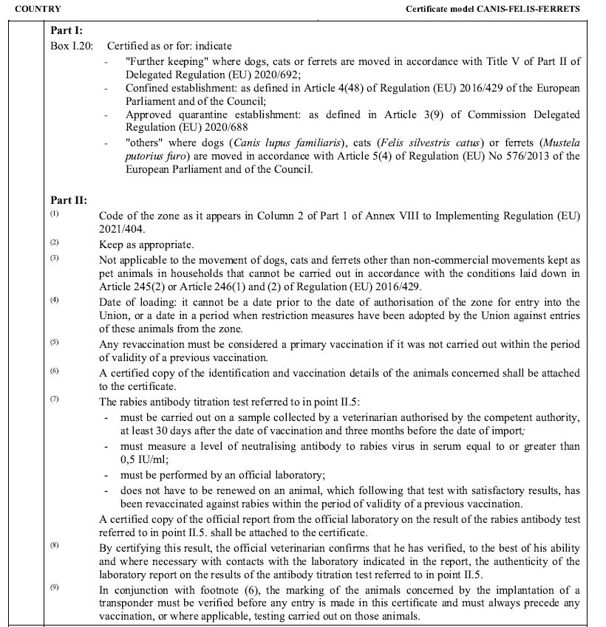

*must be filled in by competent authority*

**Country of origin**

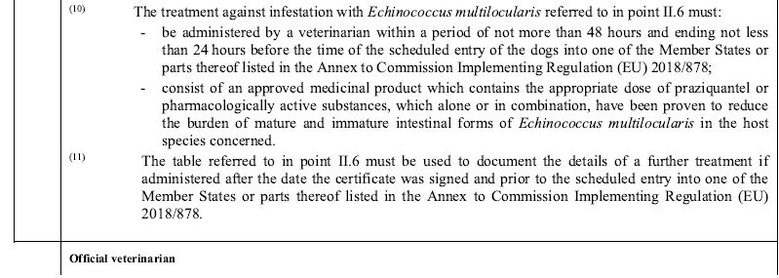



Competent authority!